**Understanding the code**

Using Arduino we processed the data for attention level of the person. Following is the reference site to perform the above action:

<https://learn.sparkfun.com/tutorials/hackers-in-residence---hacking-mindwave-mobile>

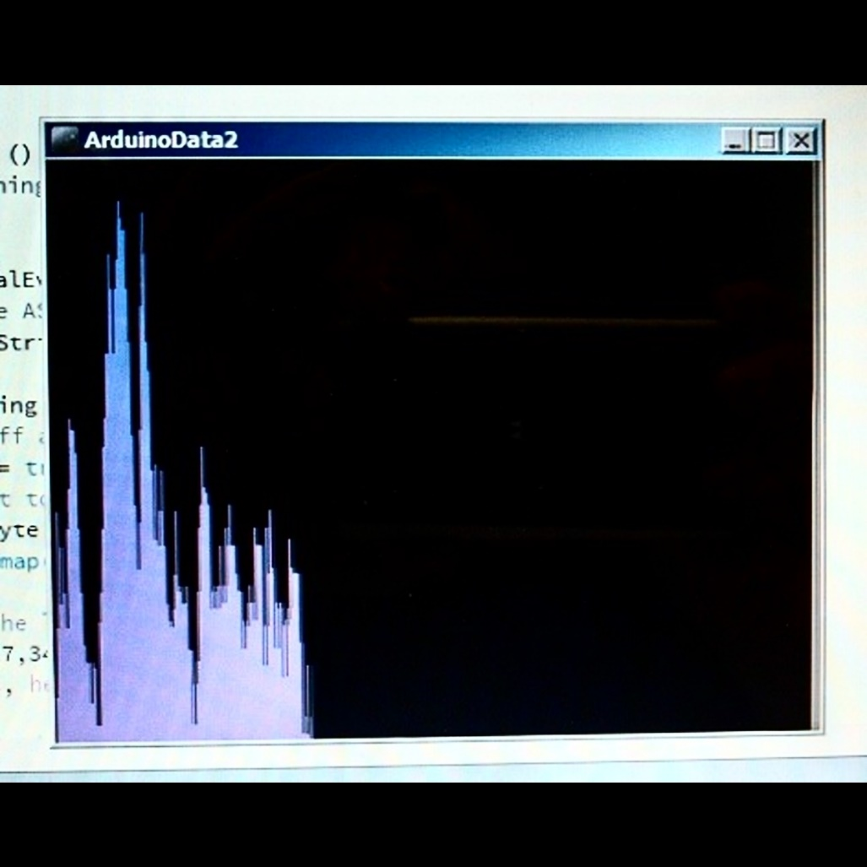

**Steps:**

* Download the Processing software for Arduino.
* Burn the programs present in the above site for attention level detection.
* Wear the headset on the head.
* Observe the graph on your laptop/PC.

**Program Descriptions:**

1. **Program to display on LCD and LED bar graph the attention level of the person**
   1. **Algorithm :**

* Initialize all required ports.
* Check for two consecutive SYNC bytes ‘AA’.
* Check for third byte which is the payload length.
* If payload length is 0x20, then store the next 32 bytes in an array. If payload length is 0x04 then move to step no. 11
* Calculate the generated checksum.
* If the last byte i.e. checksum byte of the data packet is equal to the generated checksum then check for 28th byte of the array.
* If 28th byte is 0x04, then attention detected.
* Then 29th byte indicates attention level of the person between 0-100.
* If attention level lies between 0-10, it indicates mind wandering level. Indicated it with 1 LED glow.
* If attention level lies between 10-30, it indicates poor attention level. Indicate with 2 to 3 LEDs glow.
* If attention level lies between 40-60, it indicates neutral. Indicate it with 4-5 LEDs glow.
* If attention level lies between 60-80, it indicates slightly elevated. Indicate with 6-7 LEDs glow.
* If attention level is above 80, it means elevated level of attention. Indicate with all LEDs glow.
  1. **Flowchart:**

Start

Check for two consecutive sync bytes ‘AA’

If payload length is 0x20

No

Yes

Store next 32 bytes in an array which is payload data.

Calculate the generated checksum.

Check the checksum byte i.e. the last byte of the packet.

If generated checksum is equal to checksum

Yes No

Check for 28th byte of the array. If it is 0x04 then attention is detected.

The next byte to that indicates attention level of the person.

Depending upon attention level give the velocity and glow the LED bar graph.

Stop

Repeat the program until sensor is removed from head

1. **Program to control Firebird V using Attention level and eye-blink.**
   1. **Algorithm:**
2. Initialize all required ports.
3. Check for two consecutive SYNC bytes ‘AA’.
4. Check for third byte which is the payload length.
5. If payload length is 0x20, then store the next 32 bytes in an array. If payload length is 0x04 then move to step no. 11
6. Calculate the generated checksum.
7. If the last byte i.e. checksum byte of the data packet is equal to the generated checksum then check for 28th byte of the array.
8. If 28th byte is 0x04, then attention detected.
9. Then 29th byte indicates attention level of the person between 0-100.
10. Give velocity to the bot depending on the attention level.
11. Check for 1st byte of the array. If it is 0x02, then next byte to it should be 0x00, then eye-blink can be detected.
12. If payload length is 0x04, then store the next 4 bytes in an array.
13. Store the 1st and 2nd byte after 0x02 of the array in a variable and keep adding it for next 100 data packets.
14. After taking average by 100, Eye-blink strength is between 110 and 350 and raw data values ranges above 350.
15. Now repeat from step 11 and 12 three times and check the eye-blink strength.
16. If eye- blink is given then its value will range between 110 and 350.
17. Detection of such two eye-blinks will turn the bot left.
18. In order to stop the bot, remove the sensor from head. It will give values above 350.
    1. **Flowchart:**

Start

Check for two consecutive sync bytes ‘AA’

If payload length is 0x20

If payload length is 0x04

No No

Yes Yes

Store next 32 bytes in an array which is payload data.

Calculate the generated checksum.

Check the checksum byte i.e. the last byte of the packet.

If generated checksum is equal to checksum

Yes No

Check for 28th byte of the array. If it is 0x04 then attention is detected.

The next byte to that indicates attention level of the person.

Depending upon attention level give the velocity and glow the LED bar graph.

Check for 1st byte to be 0x02. If it is 0x02 then next byte should be 0x00 for detection of eye-blink.

Store the next 4 bytes in an array

Calculate generated checksum using the bytes stored in the array.

If generated checksum is equal to checksum

Yes No

Check the next two bytes after 0x02 from the array.

Repeat the same for next 100 samples and keep adding it in a variable of 16 bit length

Divide the variable by 100. Do the same for next 3 times and again divide it by 3.

If the value lies between 110 and 350 then it is eye-blink strength.

If the value lies above 350 then raw-data values detected which will stop the bot from moving.

Detection of two eye-blinks will give left turn otherwise it will move forward.

Repeat the same until sensor is removed from head.

Stop

In this way if you understand the concept of data packets and analysed the data values properly it is possible to code for attention level, eye-blink and also for meditation level.